Presents Light Up The Night, a 5k Fundraising Event
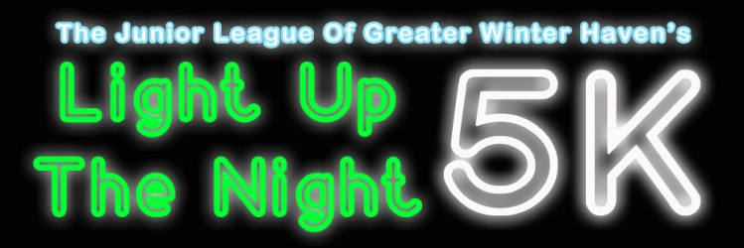

Event Information

Date: March 3, 2017
Race Time: 7pm
Race Location: Central Park, 58 Fourth St. NW, Winter Haven, FL, 33880
Race Route: 5K (3.1miles)
Parking: 220 Ave A Northwest, downtown Winter Haven

Registration Fees
Prior to February 14: $25.00
After February 14: $30.00
Day before race: $35.00
Kids and Teens: $15.00
Provide payment on Active.com

Block Party
Time: 7:00pm-10:00pm
Location: Winter Haven Central Park
Enjoy a victory party, with awards for top finishers, delicious treats from some famous food trucks, drinks and great music!

Event Questions?
Light UpTheNight@JLGWH.com
Ashley McCarthy, 863-860-8004

Presents Light Up The Night, a 5k Fundraising Event
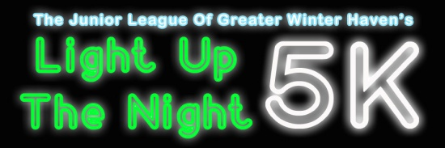
Sponsorship Opportunities

Presenting Sponsor: $1750-$2500
- Top billing on all printed materials, including runners’ t-shirts, & announcements throughout event.
- Free Race Entry for 10 Participants
- Name on Event Banner and all pre-race signage and promotions
- Exclusive announcement of the start of the race by your company
- 10 x 10 Premium Booth space at the event

Race Sponsors: $900-$1250
- Listing on all printed materials, including runners’ t-shirts, and announcements throughout the event.
- Free Race Entry for 6 Participants
- Name on all pre-race signage and promotions
- 10 x10 Booth space at the event

Leadership Sponsor: $500-$750
- Name on all pre-race signage and promotions, including runners’ t-shirts
- Free Race Entry for 4 Participants
- 10 x10 Booth space at the event

Glow Sponsor: $300-$450
- Name on all pre-race signage and promotions, including runners’ t-shirts
- Free Race Entry for 2 Participants

In-Kind Sponsor
- Benefits based on donation
- Examples include covering the cost of drinks, participant race bags, water bottles, the band, trophies, start/finish line, etc.

Sponsor Contact Info
Name
Phone/Email
Sponsorship Level

Thank you for your support!

Payment Information
Contact Name
Contact Number/Email
Payment for Runners | Active.com
Payment for Sponsors | Checks Preferred
Payment for Food Trucks | Checks Preferred
Checks Payable to | JLGWH
Mailing Address | Post Office Box 7161 Winter Haven, FL 33883-7161

Event Questions?
Light UpTheNight@JLGWH.com
Ashley McCarthy, 863-860-8004

Who are we?
The Junior League of Greater Winter Haven, Inc. is an organization of women committed to promoting voluntarism, developing the potential of women, and improving communities through the effective action and leadership of trained volunteers. Its purpose is exclusively educational and charitable. The League is made up of more than 50 active members and more than 75 sustaining members.

The Junior League of Greater Winter Haven, Inc. was founded in 1981 and joined the Association of Junior Leagues International in 1980. One of the earliest projects of the Junior League of Greater Winter Haven, Inc. was the Women’s Resource Center.

Today, we continue a tradition of service to the community with projects throughout the Greater Winter Haven area. League members donate thousands in volunteer hours annually by participating in various community projects.

Our Community Projects
The Mobile Food Bus
We at the Junior League of Greater Winter are excited to present our newest project to the community, The JL Bus. The bus visits different areas of the community who are struggling to keep food on the table. The JL Bus helps gain control on child hunger in our community by delivering food items to families that have children whose nutritional needs are not being met.

Kids In The Kitchen
Kids in the Kitchen is a project that promotes child health and wellness by providing lessons and demonstrations related to the preparation of healthy meals and snacks. These lessons include learning exercises for kids, tips on nutrition, and recipes for meals and snacks. By partnering with after school programs, the league is able to provide monthly lessons to children in the community. Additionally, this project will be organizing many other events throughout the year to engage our parents, children and community to live healthy!

Teacher Mini Grants
We believe that motivated and inspiring teachers know the needs of their students best. The JLGWH awards grants up to $250 to individuals proposing innovative programs. In addition to the financial awards, JLGWH also offers volunteer hours from members to help teachers in the community. Grants are open to all public and private school teacher in the Greater Winter Haven Area including Winter Haven, Auburndale, Bartow, Lake Alfred and Lake Wales.

Done in a Snap
This program allows the JLGWH the opportunity to work with several local charities and community events in assisting with a variety of projects that can be completed in one day (Regency Baby Fair, Salvation Army Toy Drive, The Winter Haven Hospital Citrus Classic and The Polk County Tennis Cup.)

