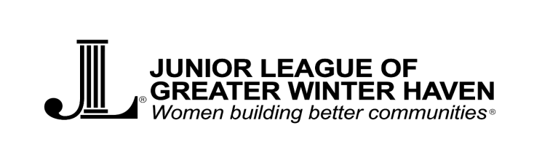
Post Office Box 7161 - Winter Haven, FL 33883-7161 - www.JLGWH.com - Federal Tax ID 59-2068148.

Presents Light Up The Night, a 5k Fundraising Event
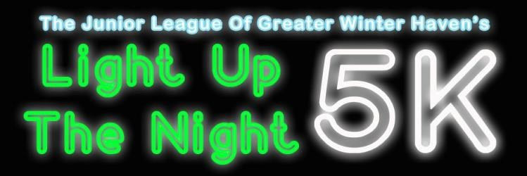
Event Information
Date: March 1, 2019
Race Time: 7pm
Race Location: Central Park, 58 Fourth St. NW, Winter Haven, FL, 33880
Race Route: 5K (3.1miles)
Parking: 220 Ave A Northwest, downtown Winter Haven

Registration Fees
Prior to February 14: $25.00
After February 14: $30.00
Kids and Teens: $15.00
65 years old+: $15.00
Provide payment on Active.com
***The school with the most race participants will be awarded with a $100 educational mini-grant!*** Please provide school name during registration on Active.

Block Party & Award Ceremony
Time: 7:00pm-10:00pm
Location: Grove Roots Packing House, 302 3rd Street SW, Winter Haven, FL
33881
Enjoy a victory party, award ceremony, delicious treats from some famous food
trucks, drinks and great music!

Event Questions?
LightUpTheNight@JLGWH.com

Post Office Box 7161 - Winter Haven, FL 33883-7161 - www.JLGWH.com - Federal Tax ID 59-2068148.

Presents Light Up The Night, a 5k Fundraising Event

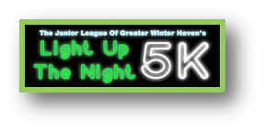

Presenting Sponsor: $2500
Sponsorship Opportunities

- Top billing on all printed materials, including runners’ t-shirts and banners, & announcements throughout event.
- Pre-race promotions on social media and inclusion of any marketing materials in pre-race packet
- Exclusive announcement of the start of the race by your company
- Business Logo on the JGLWH Website for a year as our community sponsor
- Free Race Entry for 10 Participants
- Thank you plaque
- **Please send a representative to be present at Grove Roots during the award ceremony for recognition of your sponsorship.

Race Sponsors: $1000
- Listing on all printed materials, including runners’ t-shirts and banners, and announcements throughout the event.
- Pre-race promotions on social media and inclusion of any marketing materials in pre-race packet
- Business Logo on the JGLWH Website for six (6) months as our community sponsor
- Free Race Entry for 6 Participants
- Thank you plaque
- **Please send a representative to be present at Grove Roots during the award ceremony for recognition of your sponsorship.

Leadership Sponsor: $500
- Name on all printed materials, including runners’ t-shirts
- Pre-race promotions on social media and inclusion of any marketing materials in pre-race packet
- Free Race Entry for 4 Participants
- Thank you plaque

Glow Sponsor: $300
- Name on all printed materials, including runners’ t-shirts
- Pre-race promotions on social media and inclusion of any marketing materials in pre-race packet
- Free Race Entry for 2 Participants

In-Kind Sponsor
- Benefits based on donation
- Examples include covering the cost of trophies, awards, shirts, the band, start/finish line, etc.

Post Office Box 7161 - Winter Haven, FL 33883-7161 - www.JLGWH.com - Federal Tax ID 59-2068148.

Sponsor Contact Info
Name
Phone/Email
Sponsorship Level

Thank you for your support!

Payment Information
Contact Name
Contact Number/Email
Payment for Runners | Active.com
Payment for Sponsors | Checks Preferred
Checks Payable to | JLGWH
Mailing Address | Post Office Box 7161 Winter Haven, FL 33883-7161

Event Questions?
LightUpTheNight@JLGWH.com

Post Office Box 7161 - Winter Haven, FL 33883-7161 - www.JLGWH.com - Federal Tax ID 59-2068148.

Who are we?

The Junior League of Greater Winter Haven, Inc. is an organization of women committed to promoting voluntarism, developing the potential of women, and improving communities through the effective action and leadership of trained volunteers. Its purpose is exclusively educational and charitable. The League is made up of more than 50 active members and more than 75 sustaining members.

The Junior League of Greater Winter Haven, Inc. was founded in 1981 and joined the Association of Junior Leagues International in 1980. One of the earliest projects of the Junior League of Greater Winter Haven, Inc. was the Women’s Resource Center.

Today, we continue a tradition of service to the community with projects throughout the Greater Winter Haven area. League members donate thousands in volunteer hours annually by participating in various community projects.

Our Community Projects

The Mobile Food Bus
We at the Junior League of Greater Winter are excited to present our newest project to the community, The JL Bus. The bus visits different areas of the community who are struggling to keep food on the table. The JL Bus helps gain control on child hunger in our community by delivering food items to families that have children whose nutritional needs are not being met.

Kids In The Kitchen
Kids in the Kitchen is a project that promotes child health and wellness by providing lessons and demonstrations related to the preparation of healthy meals and snacks. These lessons include learning exercises for kids, tips on nutrition, and recipes for meals and snacks. By partnering with after school programs, the league is able to provide monthly lessons to children in the community. Additionally, this project will be organizing many other events throughout the year to engage our parents, children and community to live healthy!

Teacher Mini Grants
We believe that motivated and inspiring teachers know the needs of their students the best.
The JLGWH awards grants up to $250 to individuals proposing innovative programs. In addition to the financial awards, JLGWH also offers volunteer hours from members to help teachers in the community. Grants are open to all public and private school teacher in the Greater Winter Haven Area including Winter Haven, Auburndale, Bartow, Lake Alfred and Lake Wales.

Stork Pile Project
The Stork Pile Project is in place to help less fortunate new moms when they leave the hospital. Our goal is to provde about 12-14 baskets to our local women’s hospital. The laundry baskets double as a sleeping aid for the baby so they do not co-sleep with a new mom. The baskets are filled with necessities such as blankets, diapers, diaper cream, bibs, onesies, socks, first aid kit and more.

